ISM4113: Systems Analysis and Design
Team Name: Byte Solutions
Date: December 4th, 2025

Team Members:

Lawson Wright
Alex Isidron
Chloe Jenkins
Hayley Geiger
Kylie Alvarez
Madison McNab
Peter Gorelik
Shay Springer

0.1 Table of Contents
0.0 Preface _________________________________________________________________
0.1 Table of Contents ________________________________________________________
0.2 Document History ________________________________________________________
1.0 Overview and Team Background
0.0 Preface Error! Bookmark not defined.
0.1 Table of Contents 2
0.2 Document History 4
Section 1: Overview and Team Background 5
1.1 Who We Are 5
1.2 Meet the Team 6
1.3 Business Problem Narrative 7
1.4 High Level Conceptual Diagrams 8
Section 2: Approach and Methodology 8
2.1 Agile Implementation 8
Section 3: Project Schedule with Work Breakdown Structure 11
Section 4: Sample Draft Requirements 11
4.1 Structured Questions 11
4.2 Process Requirements 14
I. Core Business Objectives and Strategic Requirements (1–30) 14
II. Stakeholder Tools and Functional Requirements (31–150) 15
A. Student Profile and Career Builder (31–65) 15
B. Trait Trackers (66–80) 16
C. Priority Matrix Tool (81–90) 17
D. University Selector and Community Builder (91–105) 17
E. Employer Specific Requirements (106–120) 18
F. Actor Data Access and Privacy (121–135) 18
G. General Functionality (136–150) 19
III. Technology, Data, and A.I. Requirements (151–210) 20
A. Data Management (151–170) 20
B. Knowledge Management System (KMS) (171–180) 20
C. A.I. Functionality and Design (181–210) 21
IV. Proposal and Project Management Requirements (211–300) 22
A. Proposal Structure and Content (211–240) 22
B. Project Management Office (PMO) and WBS (241–260) 23
C. Deliverables and Quality (261–300) 24
Section 5: Sample Database Design 26
5.1 Parent Entities and Child Entities 26
5.2 System Wide ERM 30
Section 6: Sample User Interface Design 30
6.1 Process Representation Model 30
6.2 Activity Diagram 32
6.3 Supporting ERM 36
6.4 Error! Bookmark not defined.
Section 7: Mock Prototype Demonstration 37
7.1 Potential Use Cases: 37
7.1.1 Student User Use Cases: 37
7.1.2 University User Use Cases: 40
7.1.3 Employer User Use Cases: 42
Financial Impact: Error! Bookmark not defined.
Introduction 44
Summary of Investment 44
ROI Timeline 45
Cost Break Down of $10M investment 45
Revenue Generation (Projected Annual Revenue Streams) 45
Section 8: Executive Readout 46
Presentation Recording Link: 46
Project Status Report Details Error! Bookmark not defined.
PROJECT STATUS REPORT APPROVALS Error! Bookmark not defined.

0.2 Document History
Version | Date | Author | Change Description
1.0 | 9.14 | Lawson Wright | - Document created  - Sharing Documents
1.0 | 10.12/25 | Everyone | - Determine Roles  - Determine Business Problem  - Analyze Scope
1.0 | 10.14 | Everyone | - Work on Wireframe Outline/Proposal Template  - Work on Business Problem
1.0 | 10.16 | Everyone | - Find and Evaluate Potential Use Case Diagrams  - Created Conceptual Diagram
1.0 | 10.21 | Everyone | - Review and Finalize Deliverable 1
2.0 | 10/25 | Everyone | - Research and Began Process Requirements  - Finalized Structured Questions
2.0 | 10/27 | Everyone | - Finalized Parent/Child Entities  - Finalized Process Requirements  - Completed Project Status Report
2.0 | 11/2 | Everyone | - Reviewed for Submission.
3.0 | 11/6 | Everyone | - Reorganized to Fit RFP  - Updated and Fixed previous sections
3.0 | 11/10 | Everyone | - Developed and Proofed Models and ERM
3.0 | 11/12 | Everyone | - Models are Added and Updated.
3.0 | 11/18 | Everyone | - Format Updated and Organized.
4.0 | 11/20 | Everyone | - Reviewed and Finalized for Submission.
4.0 | 11/23 | Everyone | - Creation of PowerPoint and Presentation Plan.
4.0 | 12/1 | Everyone | - Started Presentation Practice along with Feedback from Teammates.
4.0 | 12/3 | Everyone | - Finalized RFP and Presentation.

Section 1: Overview and Team Background

1.1 Who We Are
Founded in 2020, Byte Solutions was established with a clear purpose: to empower organizations through intelligent, data-driven innovation. Our founding team of consultants, technologists, and strategists came together with one shared belief — that technology should not only solve problems but create opportunities for people.
Over the years, Byte Solutions has evolved into a trusted consulting partner for clients seeking digital transformation, system integration, and A.I.-enabled decision-making tools. Our firm specializes in combining strategic planning, advanced analytics, and human-centered design to help clients modernize their operations and achieve measurable results.
What began as a small group of university-trained systems analysts has now grown into a multidisciplinary consulting company serving education, public sector, and enterprise clients nationwide. We take pride in helping organizations reimagine their data ecosystems to unlock long-term growth and sustainability.

1.2 Our Product
Longevity is a platform designed to bridge the gap between students and their future opportunities by creating a centralized, user-friendly tool that connects them with colleges, careers, recruiters, and professional resources. Students can explore academic programs, compare schools, discover internships and full-time positions, and engage directly with recruiters who are seeking emerging talent.
The app also offers personalized recommendations based on students’ interests, skills, and goals, helping them navigate the often overwhelming process of planning for life after high school or college. With built-in tools for messaging, application tracking, resume building, and career exploration, it empowers students to make informed decisions while giving colleges and employers a streamlined way to find qualified, motivated candidates. Ultimately, Longevity serves as a comprehensive pathway from education to meaningful employment, creating connections that support long-term success.

1.3 Meet the Team
The Team Byte Solutions consulting group is composed of systems analysts, user interface designers, and project managers working collaboratively to design and implement M&A’s proposed education-to-career solution.
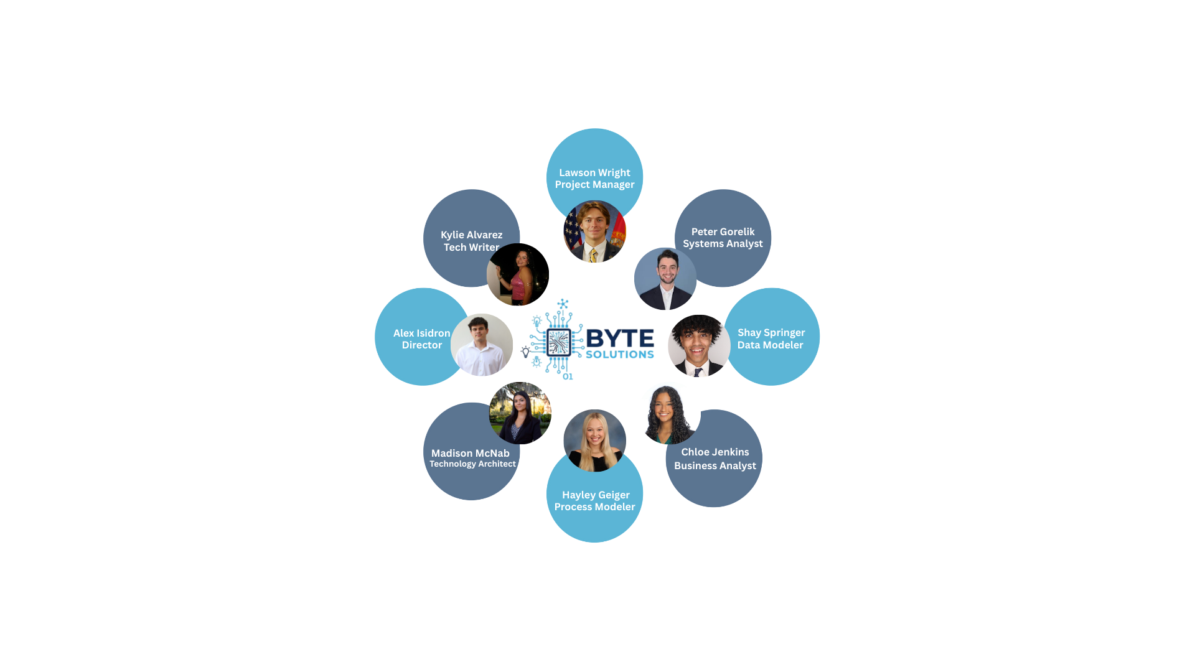
Our Roles:
Project Manager: Oversees the full lifecycle of the project, including planning, scheduling, resource coordination, risk management, and communication.
Systems Analyst: Translates business needs into detailed functional and technical specifications.
Data Modeler: Designs the data structures that support the platform’s analytics, reporting, and AI-driven functionality.
Business Analyst: Serves as the primary bridge between stakeholders and the technical team.
Process Modeler: Maps, analyzes, and optimizes the end-to-end workflows that shape user interactions and system operations.
Technology Architect: Defines the overall technical vision and ensures that the platform is built using secure, scalable, and future-ready technologies.
Director: Provides strategic leadership and oversight for the entire Byte Solutions team.
Tech Writer: Develops clear, accurate, and accessible documentation for all project deliverables, including requirements, design specifications, user guides, and training materials.
Guiding Principles & Team Rules:
- Collaboration First: Every member contributes ideas openly; decisions are made through shared consensus and respect for all perspectives.
- Transparency Always: Communication is clear, consistent, and data-driven across every stage of a project.
- Innovation Through Empathy: We design solutions that serve real human needs — not just technical requirements.
- Accountability in Action: Each team member owns their deliverables, timelines, and commitments.
- Continuous Learning: We actively seek new knowledge and stay current with emerging trends in A.I., data systems, and design thinking.
Together, these values define our culture and ensure that our partnership with Maddon & Associates produces a scalable, sustainable, and future-ready solution.

1.4 Business Problem Narrative
Students are expected to make some of their most important life decisions: choosing their major, career path, or first job based on guesswork, all at 18 years old. High school students select colleges and majors without truly understanding how they connect to real careers. They may pick majors based off trends or convenience instead of what aligns with their skills, personality, or labor market demand. Early professionals enter the workforce unprepared for the realities of workplace expectations. Meanwhile, those who realize they may have chosen the wrong path often feel trapped with debt, misaligned qualifications, and no clear roadmap for change. There is no single unified platform that guides individuals through their career journey from first exploration in high school to lifelong career development and transformation. There needs to be a platform that integrates career discovery, actionable roadmaps, skill building, and real job and mentorship connections.

1.5 High Level Conceptual Diagrams
Conceptual Diagram:
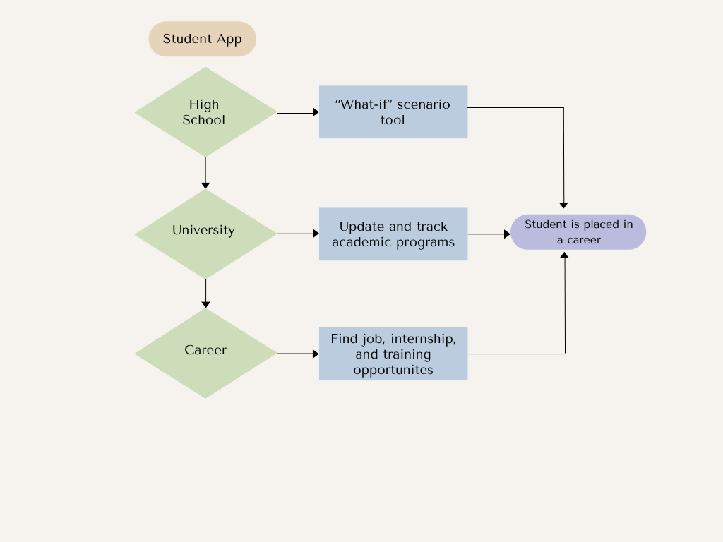

Section 2: Approach and Methodology

2.1 Agile Implementation
Project Overview and Initial Evaluation – Planning & Development
- Break down requirements for the configurable education‑to‑career platform, clarifying key outcomes such as improved post‑graduation employment/continuing‑education rates and a self‑sustaining cloud stack within three years.
- Engage with students, educators, institutions, and employers to prioritize which systems and data sources (SIS, LMS, job‑fair systems, labor‑market data) must be integrated first and define expected ROI or process improvements for each integration.
- Populate a product backlog with prioritized epics, user stories, and technical tasks that evolves as discovery continues, using agile ceremonies and refinement to keep it current.
- Define clear acceptance criteria for each user story so teams and stakeholders share a common “definition of done” for features such as career roadmaps, soft‑skill tracking, and employer‑matching.
Solution Design Assessment and Customer Collaboration
- Break down the solution into small, testable functional modules (high‑school exploration, college planning, post‑grad career launch) that can each deliver independent value while contributing to the end‑to‑end journey.
- Run frequent usability tests on each module with representative users (students, counselors, employers) and incorporate findings into design iterations to keep the product aligned with real needs.
- Partner with multiple high schools and colleges via interviews, surveys, focus groups, and beta access to gather insights on usability, equity, and institutional workflow fit.
- Involve regional and national employers early to ensure skills of taxonomies, job‑matching logic, and job‑fair workflows reflect current hiring practices and emerging roles in the labor market.
Implementation and Training – Data Collection
- Implement automated, consent‑aware data collection across key sources such as high‑school academic records, college admission requirements, credential repositories, and labor‑market/marketing insights to power recommendations and analytics.
- Provide role‑based training and in‑product guidance for students, educators, and employers, using short, iterative training cycles aligned to new feature releases.
- Scale usage gradually by onboarding additional schools, colleges, and employers in waves, using early cohorts to refine configuration templates and onboarding playbooks for broader adoption.
Monitoring and Support – Continuous Improvement
- Deploy real‑time monitoring dashboards (e.g., Power BI or custom analytics) to track key performance indicators such as engagement, pathway completion, system usage, and satisfaction scores across user groups.
- Establish a multi‑channel helpdesk (knowledge base, chatbots, ticketing, live support) for students, educators, and employers, aiming to resolve common issues quickly and minimize disruption to learning and recruiting.
- Embed continuous feedback loops using post‑interaction surveys, in‑app prompts, and quarterly user councils so insights regularly flow into backlog refinement and process improvements.
Evaluation and Feedback – Reflect and Adjust
- Analyze collected data and qualitative feedback at the end of each release cycle, then reprioritize backlog items to focus on the highest‑impact enhancements and new capabilities.
- Conduct at least an annual strategic review with M&A and key partners to test whether the platform is still aligned to the original vision, evolving user needs, and market realities, adjusting roadmap and KPIs as needed.
- Systematically review criticisms, pain points, and adoption barriers, converting them into improvement experiments and measurable action items for upcoming sprints.

Section 3: Project Schedule with Work Breakdown Structure
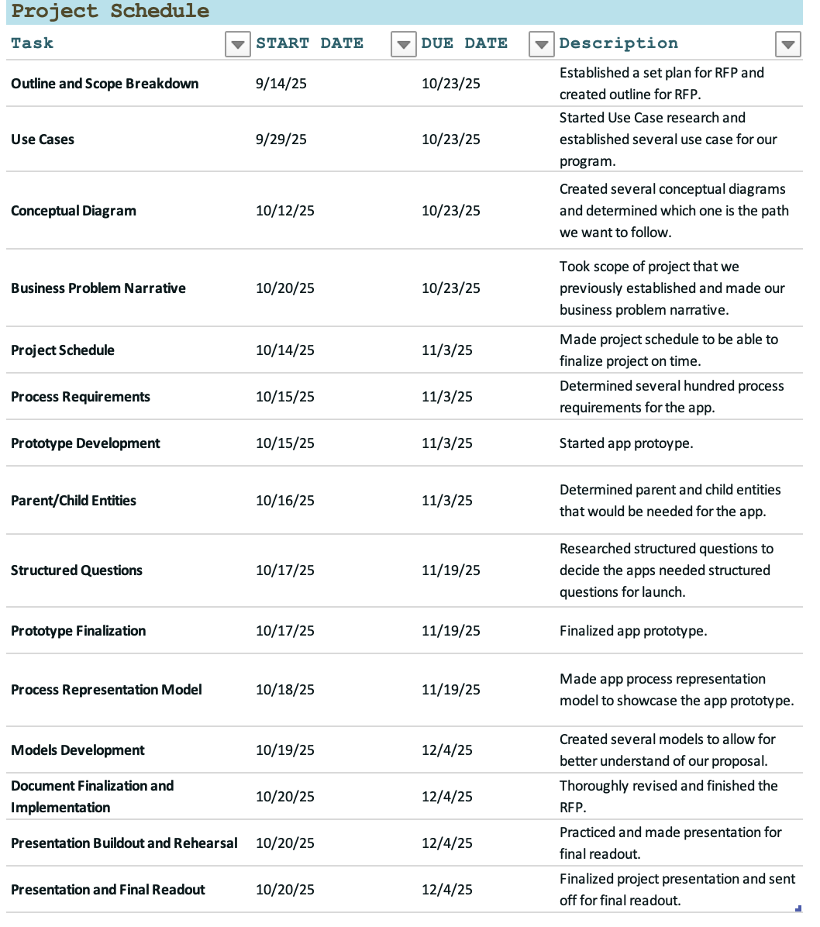

Section 4: Sample Draft Requirements

4.1 Structured Questions
1. What are the main goals of the system?
- To help students plan and track their educational and career pathways.
- To connect students with advisors, alumni, and employers.
- To provide universities with data on student engagement and success outcomes.
2. Who are the main users (actors)?
- Students
- Advisors
- Employers
- Alumni
- System Administrators
3. What main processes must the system support? (Process Requirements)
- Account creation, login, and authentication
- Career roadmap creation and tracking
- Skill and course recommendations
- Job and internship matching
- Advisor feedback and messaging
- Analytics and reporting
- Notifications and reminders
- Community/mentorship interactions
4. What main data will the system need to store and manage? (Data Requirements)
- Student data (name, GPA, major, interests, courses, goals)
- Advisor data (assigned students, feedback notes)
- Employer data (company profile, job postings, contacts)
- Job data (title, requirements, location, status)
- Career roadmap data (goals, milestones, completion status)
- Skill data (hard skills, soft skills, proficiency levels)
- Message data (sender, receiver, timestamp, message content)
- Analytics data (login activity, placement rates, progress metrics)
5. What data relationships exist between entities?
- Each student can have multiple career goals.
- Each advisor can manage multiple students.
- Each employer can post multiple jobs.
- Each job can receive multiple student applications.
- Each student can have multiple skills.
- Each student can interact with multiple advisors and alumni.
6. What security or access rules apply?
- Students can only view and edit their own data.
- Advisors can only view assigned student profiles.
- Employers can only view matched student candidates.
- Admins can view and manage all data.
- Sensitive data (like GPA or personal info) must be encrypted.
7. What outputs or reports will the system generate?
- Career progress reports
- Advisor feedback summaries
- Job application summaries
- Skill gap analysis
- Employer engagement metrics
- System usage reports
8. What are the main external systems or integrations (if any)?
- University Student Information Systems (SIS)
- LinkedIn API (for job data or alumni connections)
- Email notification services

4.2 Process Requirements

I. Core Business Objectives and Strategic Requirements (1–30)
- The system must support the vision of M&A to be the leader in innovative thinking and problem solving.
- The system must yield a return on investment (ROI) within 24–36 months.
- The system’s operations must be self-sustaining after three years.
- The system must capture the knowledge of M&A partners and associates.
- The system must generate knowledge and provide valuable insights.
- The system must incorporate M&A’s intellectual property of generating insights and problem solving.
- The system must provide a career roadmap focused on values, interests, and skills.
- The system must focus on post-graduation outcomes, including employment and/or continuing education.
- The system must modernize the talent pipeline from high school through college and into the workforce.
- The system must tightly couple students into the pipeline leading to successful careers.
- The system must support the Career Placement decision model (estimated at $3m to $5m).
- The system must track post-graduation impact metrics (The Next Generation).
- The solution must support financial forecasts and cost/benefit analysis.
- The solution must support risk analysis and benefits realization.
- The system must allow for the customization of the student lifecycle roadmap illustration.
- The system must track student progression through the "Engage 100" milestone.
- The system must track student progression through the "Professional Development (GEB)" milestone.
- The system must track student progression through the "Associate of Arts" milestone.
- The system must track student progression through the "College of Business (Undergraduate)" milestone.
- The system must track student progression through the "Confirmation / Alignment" milestone.
- The system must measure post-graduation outcomes data.
- The system must track the value generated by employer development.
- The system must track the value generated by internship experience.
- The system must support an ecosystem that is a starting point for the overall vision.
- The system must provide a mechanism to track the career decision based on a starting salary of $70k.
- The system must factor in an annual expected salary increase of 5%.
- The system must model a 30-year career trajectory for financial forecasting.
- The solution must provide flexibility to accommodate various data formats.
- The solution must be technology agnostic.
- The solution must support a plethora of data/technology platforms.

II. Stakeholder Tools and Functional Requirements (31–150)

A. Student Profile and Career Builder (31–65)
- The system must allow a student to build a comprehensive profile and template.
- The system must allow students to shape their education choices (e.g., majors, minors) to potential opportunities.
- The system must incorporate assessments (e.g., Myers-Briggs, DISC, Clifton Strengths) into the profile.
- The system must allow students to view available career opportunities and the required education/experience.
- The system must link specific skills, including soft skills like relationship building, to employment opportunities.
- The system must provide data on starting salary range.
- The system must provide data on average benefits packages.
- The system must list skills expected to launch a career.
- The system must allow students to explore types of careers available.
- The system must provide information on majors and experiences offered by a college to launch a career.
- The system must display the job market outlook.
- The system must forecast a person's income and expenses for 1-year, 3-year, 5-year, and 10-year outlooks.
- The system must incorporate how wealth management factors into career growth.
- The system must allow students to search for companies interested in recruiting from universities.
- The system must provide career growth information for specific industries.
- The system must detail the industries and marketplaces served by recruiting companies.
- The system must allow students to save and compare different career roadmaps.
- The system must track a student's acquisition of specific hard skills (e.g., technical certifications).
- The system must track a student's participation in relevant professional development activities.
- The system must allow students to rate the usefulness of career advice provided by the system.
- The system must provide personalized alerts when a new job posting matches the student profile.
- The system must allow students to set custom career goals and track progress against them.
- The system must include a simulation or modeling tool for different education paths.
- The system must allow students to upload and store professional documents (e.g., resume, cover letters).
- The system must provide a dashboard to visualize skills gaps relative to a target job.
- The system must guide a student through the initial "High School (Select College)" phase.
- The system must provide resources related to the internship experience.
- The system must provide resources related to employer development opportunities.
- The system must support the student in the final career placement process.
- The system must use student profile data to personalize career content.
- The system must allow students to update their values and interests annually.
- The system must provide links to external career readiness resources (e.g., NACE).
- The system must include a feature for students to track their job application history.
- The system must provide a clear, understandable representation of career growth over 30 years.
- The system must provide tools to help students determine "What do I want to do with my life?"

B. Trait Trackers (66–80)
- The system must include an External Trait Tracker to identify innovative and new talent.
- The External Trait Tracker must use surveys to collect student data.
- The External Trait Tracker must use databases to store student data.
- The External Trait Tracker must track students' achievements throughout their schooling.
- The External Trait Tracker must identify when traits and skills thrive the most in M&A.
- The External Trait Tracker's output must identify attractive candidates based on their traits.
- The system must include an Internal Trait Tracker for M&A's highest performers.
- The Internal Trait Tracker must perform an internal deep dive into the traits and backgrounds of high performers.
- The Internal Trait Tracker must collect internal data as input.
- The Internal Trait Tracker's output must be the traits of the highest performers.
- The system must input the highest performer traits into the External Trait Tracker.
- The External Trait Tracker must track specific inputs like "Person traits and skills."
- The Internal Trait Tracker must be secure to handle sensitive internal performance data.
- The system must allow recruiters to search the External Trait Tracker based on Internal Trait outputs.
- The system must visualize the correlation between external student traits and internal high-performer traits.

C. Priority Matrix Tool (81–90)
- The system must include a Priority Matrix tool for students.
- The tool must help students identify activities and priorities.
- The tool must categorize tasks by Sense of Urgency (Low to High).
- The tool must categorize tasks by Importance (Low to High).
- The tool must display Quadrant 1 (High Priority, High Urgency) tasks as "Do it Now".
- The tool must display Quadrant 2 (High Priority, Low Urgency) tasks as "Plan it and then do it".
- The tool must display Quadrant 3 (Low Priority, High Urgency) tasks as "delegate it, question it".
- The tool must display Quadrant 4 (Low Priority, Low Urgency) tasks as "eliminate it".
- The tool must visually emphasize Q2 as the highest quality space.
- The tool must provide context or warnings about Q1 and Q3 as being the highest stress spaces.

D. University Selector and Community Builder (91–105)
- The system must include a University Selector student tool.
- The University Selector must help high school students prioritize college choices based on factors.
- The University Selector must allow students to filter by college cost.
- The University Selector must allow students to filter by college location.
- The University Selector must allow students to filter by types of degrees offered.
- The system must include a Community Builder tool.
- The Community Builder must help universities stay connected with students after they move into their careers.
- The Community Builder must support alumni using the University to recruit.
- The Community Builder must support alumni using the University to invest.
- The Community Builder must support alumni using the University to grow.
- The Community Builder must allow for alumni investment tracking and reporting.
- The system must support University Employees (e.g., Advisor, Faculty) as actors.
- The system must support the flow of information between a university and its alumni (Community Builder).
- The University Selector must allow the comparison of up to five different universities simultaneously.
- The Community Builder must integrate with university Customer Relationship Management (CRM) systems.

E. Employer Specific Requirements (106–120)
- The system must support companies recruiting students into the workforce as actors.
- The Career Builder tool must allow employers to enter job descriptions.
- The Career Builder tool must allow employers to enter timelines for hiring.
- The Career Builder tool must allow employers to enter other relevant information.
- The system must provide employers with a dashboard of matching student candidates.
- The system must allow employers to filter candidates based on demonstrated soft skills.
- The system must allow employers to search for students based on psychometric assessment results (e.g., Myers-Briggs).
- The system must provide aggregate data on student career preferences to employers.
- The system must allow employers to schedule interviews with matched candidates.
- The system must allow employers to provide feedback on the interview process (for A.I. training).
- The system must track employer participation in job fairs (to link skills).
- The system must provide employers with detailed reports on the ROI of their recruiting via the platform.
- The system must allow employers to flag job descriptions for immediate attention by relevant university career centers.
- The system must include a feature for employers to post virtual/remote opportunities.
- The system must allow employers to browse student profiles by education choices (e.g., specific majors).

F. Actor Data Access and Privacy (121–135)
- The system must enforce role-based access control (RBAC) to ensure students can only view their own data and public employer/university data.
- The system must ensure University Advisors can only access data for students assigned to them.
- The system must ensure Employers can only access anonymized or pre-approved candidate profile data.
- The system must provide a mechanism for students to consent to sharing assessment data.
- The system must anonymize data used for macro-level financial forecasts and risk analysis.
- The system must provide a clear privacy policy accessible to all actors.
- The system must include a process for data deletion requests in compliance with privacy laws.
- The system must use secure login methods (e.g., multi-factor authentication) for all actors.
- The system must log all user activity to maintain an audit trail.
- The system must encrypt sensitive data (e.g., financial forecasts, assessment scores) both in transit and at rest.
- The system must ensure data views for University Faculty are limited to aggregate skill trends.
- The system must ensure data views for alumni in the Community Builder are opt-in and controlled by the alumnus.
- The system must prevent unauthorized data extraction (e.g., rate limiting on API calls).
- The system must provide data segregation between different universities using the system.
- The system must ensure the internal data collected by the Internal Trait Tracker remains confidential to M&A.

G. General Functionality (136–150)
- The system must allow users to access the platform via standard web browsers.
- The system must provide an intuitive and user-friendly interface design (UID).
- The system must include search functionality for all content, including the KMS.
- The system must support data visualizations for decision-making needs.
- The system must provide in-app notifications for key milestones (e.g., application deadlines).
- The system must include a mechanism for providing user feedback on system quality.
- The system must have a robust help and support section for all tools.
- The system must allow for the export of personalized student career data.
- The system must provide a version control mechanism for the documents stored in the KMS.
- The system must allow University Employees to send mass notifications to groups of students.
- The system must track user sessions for performance monitoring.
- The system must include a mechanism for reporting data quality issues.
- The system must provide a dashboard summarizing key operational health metrics.
- The system must support single sign-on (SSO) integration where applicable.
- The system must be designed for full accessibility standards (e.g., WCAG compliance).

III. Technology, Data, and A.I. Requirements (151–210)

A. Data Management (151–170)
- Multiple data sources must be fed into a centralized database.
- The system must address data management needs for gathering information.
- The system must address data management needs for cleansing information.
- The system must support data visualizations for the organization.
- The centralized database architecture must be specified (e.g., relational, NoSQL, data lake).
- The data cleansing process must include standardization and deduplication steps.
- The data ingestion process must handle various data formats (e.g., JSON, CSV, XML).
- The system must include a data governance framework for data lineage and ownership.
- The system must define data retention and archival policies.
- The database must be scalable to accommodate long-term student and alumni data over decades.
- The system must include a separate analytical data store (e.g., data warehouse) for financial forecasting.
- The system must provide versioning for data schemas to manage changes.
- The system must include automated checks for data quality before A.I. ingestion.
- The system must track data freshness and latency metrics.
- The system must include error logging and alerts for data pipeline failures.
- The system must support real-time data streaming for critical A.I. features.
- The system must define metadata standards for all ingested data sources.
- The data transformation process must normalize assessment scores from different psychometric tests.
- The data management system must be geographically distributed for disaster recovery.
- The system must allow for ad-hoc data querying by M&A analysts.

B. Knowledge Management System (KMS) (171–180)
- The solution must include a knowledge management system (KMS).
- The KMS must store knowledge for industry-specific business questions.
- The KMS must store knowledge related to various projects.
- The KMS component must be part of the system architecture.
- The KMS must be searchable by keyword, category, and partner/associate author.
- The KMS must support multiple file types (e.g., documents, presentations, video links).
- The KMS must include a feature for M&A partners to validate and certify knowledge articles.
- The system must provide A.I.-driven categorization of new KMS inputs.
- The KMS must integrate with the A.I. decision-making tools to provide context/explanations.
- The KMS must have a defined review cycle for content to ensure relevance and accuracy.

C. A.I. Functionality and Design (181–210)
- The solution must provide a comprehensive design that leverages A.I. technology.
- The A.I. technology must be implemented for the good of the system and the customer.
- The A.I. must support the construction of financial forecasts.
- The A.I. component must address what types of decisions are relevant to the business problem.
- The A.I. component must define the supporting data constructs.
- The solution design must include choices and costs for building A.I. capabilities.
- The solution design must include choices and costs for buying A.I. capabilities.
- The A.I. must use data constructs to track the 33,000 to 35,000 decisions an average adult makes daily.
- The A.I. must be used to identify high-impact career and financial decisions to reduce decision fatigue.
- The A.I. must implement a career recommendation model based on student profiles.
- The A.I. must analyze job descriptions via Natural Language Processing (NLP) to extract required skills.
- The A.I. model must provide a confidence score for student-job matches.
- The A.I. must be used for risk analysis on career paths (e.g., probability of career misalignment).
- The A.I. should incorporate a feedback loop where user choices are used for model retraining.
- The A.I. must provide an explainability feature (XAI) for its recommendations to foster user trust.
- The A.I. financial model must estimate the long-term impact of wealth management choices.
- The A.I. must be used to categorize unstructured data (e.g., survey results, student achievements) for the Trait Trackers.
- The A.I. must support scenario modeling for "what-if" analyses in the Career Builder.
- The A.I. platform must be clearly specified (e.g., cloud provider, specific services).
- The A.I. design must justify the choice of front-end technology.
- The A.I. must provide an output for the estimated career growth look like in 1-year, 3-year, 5-year, and 10-year outlooks.
- The A.I. must correlate alumni giving/recruiting behavior with their student-stage data.
- The A.I. must identify the necessary skills for a career launch.
- The A.I. model training process must be detailed in the proposal.
- The A.I. models must be continuously monitored for drift or degradation in performance.
- The A.I. must predict the job market outlook.
- The A.I. model must provide a risk score based on the chosen education path.
- The A.I. must provide universities with projections on student career success.
- The A.I. must analyze industry and marketplace data to predict career growth.
- The A.I. must assist in cost/benefit analysis.

IV. Proposal and Project Management Requirements (211–300)

A. Proposal Structure and Content (211–240)
- The proposal must clearly articulate the necessary schedule.
- The proposal must clearly articulate the necessary scope.
- The proposal must clearly articulate the necessary resources.
- The proposal must provide a baseline business case outlining the cost/benefits of the $10m investment.
- The proposal must include Section 1: Overview and Team Background.
- The proposal must include Section 2: Approach and Methodology.
- The proposal must include Section 3: Project Schedule with Work Breakdown Structure (WBS).
- The proposal must include Section 4: Sample Draft Requirements (SDR).
- The proposal must include Section 5: Sample Database Design (SDD).
- The proposal must include Section 6: Sample User Interface Design (UID).
- The proposal must include Section 7: Mock Prototype Demonstration.
- The proposal must include Section 8: Executive Readout.
- The Knowledge Management component must be clearly delineated in the proposal response.
- The proposal must demonstrate Overall Professionalism (20% of score).
- The proposal submission must be professional, including a cover, table of contents, and structure.
- The proposal must demonstrate Innovation ("Wow factor") (20% of score).
- The proposal must articulate the Approach and Methodology (5% of score).
- The proposal must apply concepts learned into the proposal response.
- The proposal must represent the Business Case well (10% of score).
- The Business Case must clearly represent cost/benefit and value add parts of the solution.
- The proposal must articulate the work into manageable phases (PMO).
- The proposal must articulate the work into activities/tasks (PMO).
- The proposal must articulate the work into milestones and deliverables (PMO).
- The proposal must clearly address the level of effort (PMO).
- The proposal must provide an overall pricing structure (PMO) (show math).
- The proposal must clearly describe the roles and responsibilities of the team (Team Structure).
- The proposal must clearly outline how the team is going to govern themselves (Team Structure).
- The proposal must demonstrate how well the design artifacts (D1-D3) and Mock Prototype are presented (10% of score).
- The proposal must demonstrate how the design artifacts tie to the Mock Prototype.
- The proposal must demonstrate that the team can craft a throw-away prototype.

B. Project Management Office (PMO) and WBS (241–260)
- The WBS must include the deliverables D1 (Scope Document), D2 (Requirements Document), D3 (Design Document), and D4 (Readout Video and Materials).
- The WBS must specify the resources required for each major phase.
- The WBS must include a risk management activity for the project.
- The project schedule must specify the methodology to be used (e.g., Agile, Waterfall).
- The WBS must detail the steps for completing the throw-away prototype.
- The proposal must include a Communication Plan for stakeholders (M&A, Team, Judges).
- The WBS must allocate time for incorporating M&A's intellectual property.
- The project structure must address the $10m grant funding as a budget constraint.
- The WBS must include a phase for A.I. model training and validation.
- The proposal must define the roles and expected time commitment for each team member.
- The project must have a formal scope change request process.
- The WBS must include quality assurance and testing activities.
- The proposal must outline the strategy for minimizing project risk.
- The proposal must detail the governance process for managing team conflicts.
- The WBS must include a task for calculating the Career Placement decision model justification.
- The WBS must include tasks for data cleansing and normalization.
- The proposal must define the required toolsets (e.g., database, cloud platform, and design software).
- The WBS must include the production and submission of the Executive Readout (D4).
- The proposal must detail the team's process for self-governance.
- The WBS must include a phase for user acceptance testing (UAT) with pilot users.

C. Deliverables and Quality (261–300)
- The Scope Document (D1) must clearly define the boundaries of the system.
- The Requirements Document (D2) must detail the functional and non-functional requirements.
- The Design Document (D3) must present the database design (SDD) and user interface design (UID).
- The Executive Readout (D4) must meet the stated expectations in Section 8.
- The Executive Readout must incorporate thought leadership.
- The Executive Readout must incorporate strategic planning.
- The Executive Readout must incorporate business acumen.
- The Mock Prototype must demonstrate key functionalities of the Priority Matrix tool.
- The Mock Prototype must demonstrate a key interaction flow for one actor (e.g., student profile building).
- The Mock Prototype must clearly illustrate the proposed UID.
- The SDD (D3) must include an Entity-Relationship Diagram (ERD).
- The UID (D3) must include wireframes for the Career Builder employer portal.
- The UID (D3) must include mockups for the student dashboard.
- The UID (D3) must include design for the University Selector tool.
- The SDR (D2) must include use cases for each primary actor.
- The SDR (D2) must include constraints derived from the technology stack (SaaS/PaaS/IaaS).
- The proposal must detail the assessment process for determining the "buy vs. build" decision.
- The proposal must detail the scoring process, acknowledging the placeholder points (D1-D3) and the final percentage factored against 300 points.
- The proposal must address team positioning, acknowledging the ranking structure (100%, 92%, 88%, 80%).
- The proposal must demonstrate a quality of work that is not "way below expectation" (below 80%).
- The proposal must acknowledge the total point value is 300 points.
- The D4 materials must include the video and any supporting presentation materials.
- The proposal must detail how the team applied the Bruce Tuckman model for team evolution.
- The UID must be designed for an intuitive experience for high school students.
- The UID must ensure accessibility across various devices (mobile and desktop).
- The SDR must include security requirements (NFRs).
- The proposal must describe the method used to articulate the level of effort for the pricing structure.
- The proposal must define the success criteria for the mock prototype.
- The proposal must clearly describe the roles of University Employees (e.g., Advisor, Faculty) within the system.
- The proposal must demonstrate how the team will manage resources, acknowledging the competitive nature with 8-12 teams combined.
- The proposal must justify the front-end technology choices.
- The proposal must detail the cost components of the IaaS, PaaS, and SaaS layers.
- The D2 must explicitly detail requirements for linking specific skills to employment opportunities.
- The D3 must include a high-level network topology diagram.
- The proposal must include a contingency plan for a major project risk.
- The proposal must use professional terminology throughout (e.g., systems analysis, enterprise architecture).
- The D2 must include requirements for tracking the starting salary of $70k and the 5% increase.
- The D3 must detail the database schema for the External Trait Tracker data.
- The proposal must include a brief analysis of the National Association of Colleges and Employers (NACE) link context.
- The proposal must clearly demonstrate the completeness and quality of the team's response to achieve a high ranking

Section 5: Sample Database Design

5.1 Parent Entities and Child Entities
1. Student (Parent)
- Student_ID (Primary Key)
- First_Name
- Last_Name
- Email
- Major
- GPA
- Graduation_Year
- Career_Goal_ID (Foreign Key)
- Advisor_ID (Foreign Key)
Child Entities:
- Student_Skills
  - Skill_ID
  - Skill_Name
  - Skill_Level
- Student_Activities
  - Activity_ID
  - Activity_Name
  - Hours_Spent
  - Description
- Student_Applications
  - Application_ID
  - Job_ID
  - Date_Applied
  - Status
2. Advisor (Parent)
- Advisor_ID
- Name
- Department
- Email
Child Entities:
- Assigned_Students
  - Student_ID
  - Date_Assigned
  - Notes
3. Employer (Parent)
- Employer_ID
- Company_Name
- Industry
- Contact_Email
- Location
Child Entities:
- Job_Postings
  - Job_ID
  - Title
  - Description
  - Required_Skills
  - Salary_Range
  - Post_Date
  - Expiration_Date
- Employer_Contacts
  - Contact_ID
  - Name
  - Role
  - Phone_Number
4. Job (Parent)
- Job_ID
- Employer_ID (Foreign Key)
- Title
- Description
- Required_Skills
- Location
- Status
Child Entities:
- Applications
  - Application_ID
  - Student_ID
  - Date_Submitted
  - Result (Accepted/Rejected/Pending)
5. Career_Roadmap (Parent)
- Career_Goal_ID
- Student_ID (Foreign Key)
- Goal_Title
- Description
- Target_Completion_Date
Child Entities:
- Milestones
  - Milestone_ID
  - Career_Goal_ID
  - Step_Name
  - Completion_Status
  - Notes
6. Message (Parent)
- Message_ID
- Sender_ID
- Receiver_ID
- Message_Content
- Timestamp
Child Entities:
- Attachments
  - Attachment_ID
  - File_Name
  - File_Type
  - File_Size
7. System_Admin (Parent)
- Admin_ID
- Name
- Role
- Email
Child Entities:
- System_Actions
  - Action_ID
  - Admin_ID
  - Description
  - Action_Date

5.2 High-Level System Wide ERM
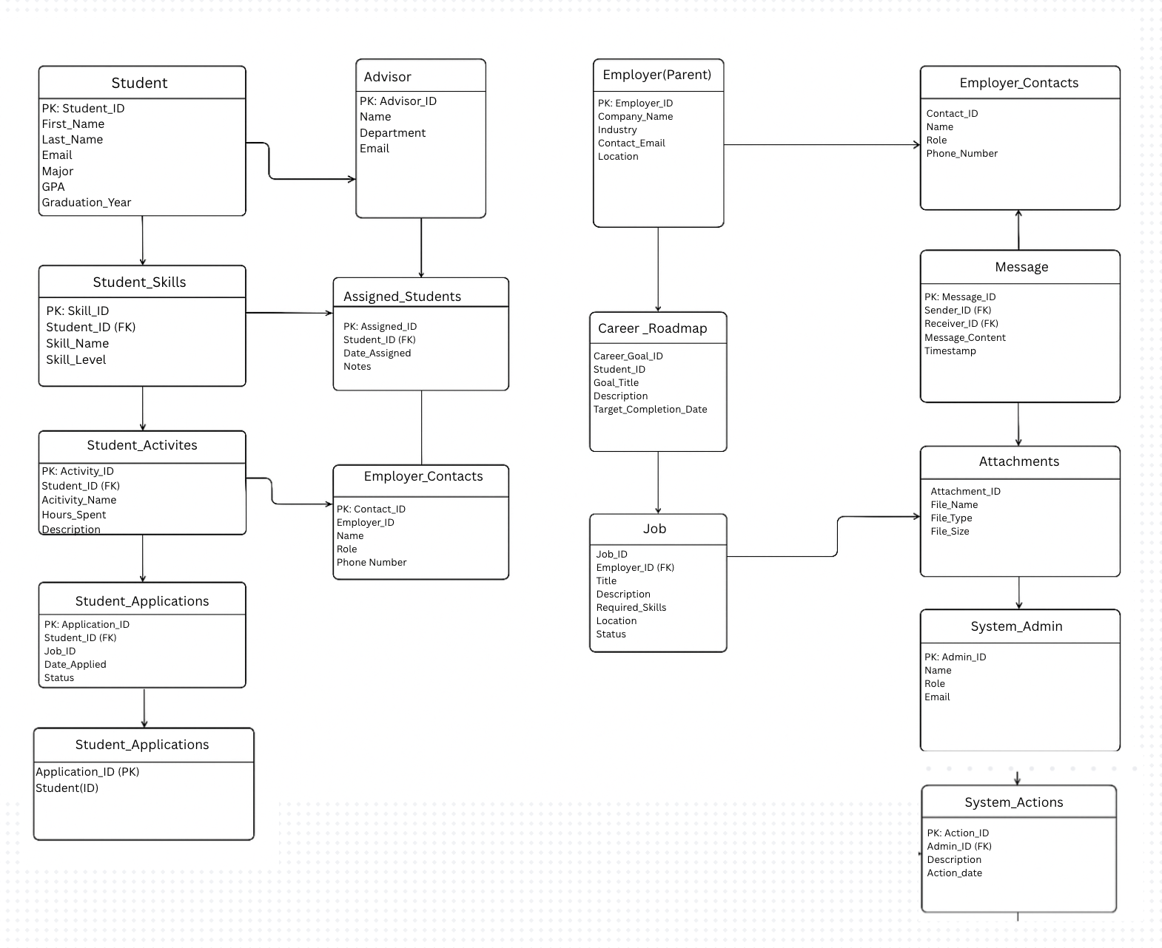

Section 6: Sample User Interface Design

6.1 Process Representation Model
Figure 1: Student Dashboard Prototype – “My Pathway Home”
The Student Dashboard is the core entry point of the system and serves as the student’s personalized home screen. The interface is designed to place the student at the center of the educational and career lifecycle. From the moment a student logs in, the dashboard provides a holistic snapshot of their academic direction, strengths, and skill progress, while clearly displaying next steps powered by AI-driven recommendations.
A universal search bar allows students to explore potential majors, careers, and relevant skills based on their interests. Quick-access smart tiles connect the student to essential tools such as Career Exploration, Strengths Assessments, Resume Builder, Courses/Majors Planning, Internships, Mentorship Pairing, and Assessment History.
The dashboard also highlights AI-recommended majors, professional pathways, and internship matches based on student personality profiles, academic performance, skills, and real labor-market demand. This visual reinforces the mission of M&A’s vision: to move students from uncertain decision-making toward informed, data-supported choices that directly connect education with long-term career outcomes.
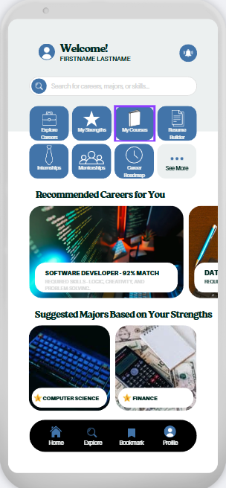
By combining assessments, skills tracking, and suggested academic/career pathways, this interface demonstrates how the system provides clarity, confidence, and direction to every student early in their journey.

Figure 2: Career Roadmap Prototype
The Career Roadmap interface visualizes the full journey a student will take from early academic exploration through professional career launch. In alignment with the RFP, this design demonstrates how technology creates a structured blueprint that connects student characteristics with education planning, skill development, real-world experience, and successful job placement.
The roadmap is organized into five distinct phases: Discover, Plan, Develop, Connect, and Launch. Each phase outlines key tasks, milestones, and deliverables such as completing assessments, identifying aligned majors, selecting coursework, building skill portfolios, pursuing internships, participating in career networks, and preparing for full-time employment.
The interface also displays visual progress bars, so students can see how far they’ve progressed. An AI-Insights bar provides personalized and dynamic recommendations such as courses to take next, skills to level up, or internship opportunities aligned with a student’s projected pathway and talent profile.
This visual reinforces the student as the primary decision-maker in their own journey while ensuring they are never alone. Instead of navigating academic and career decisions blindly, the student receives an intelligent, structured, and guided roadmap that ties their academic progression directly into a realistic career pathway.
This design directly reflects the RFP’s requirement to improve post-graduation readiness and workforce transition, ensuring students graduate with clear skills, direction, and employment opportunities.
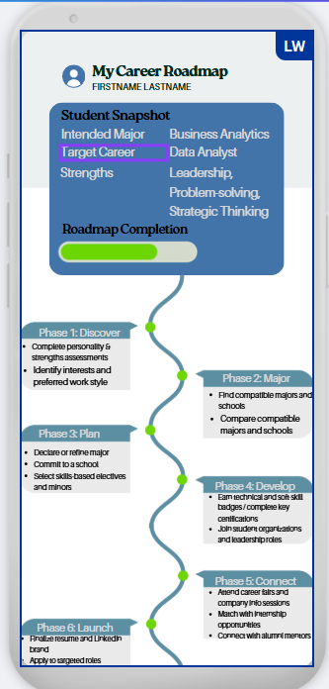
Figure 3: Internship & Career Matching Portal Prototype
The Opportunities Portal demonstrates how the platform transitions students from academic planning into real employment pipelines. This interface showcases AI-generated job and internship matches aligned to each student’s strengths, interests, skills, assessment results, and academic profile. Each listing displays match scores, hiring timelines, salary ranges, required competencies, and recommended upskilling needs.
To maximize employment outcomes, students are immediately presented with actionable opportunities such as internships, entry-level positions, apprenticeship programs, research roles, co-op placements, and mentorship partnerships. Smart filters allow students to explore industries, job types, compensation brackets, and hiring location preferences.
The design also includes talent-insight metrics like projected starting salary estimates, industry growth rates, and employer conversion likelihood. This emphasizes data-driven decision support, as defined within the RFP’s technology and knowledge-driven architecture expectations.
Most importantly, this page visually proves that the solution leads to ROI-driven outcomes. It confirms the system’s ability to strengthen career readiness, job placement rates, and long-term alumni success. Students benefit by gaining clear entry points into the workforce, while employers benefit from access to high-potential, pre-vetted candidates.
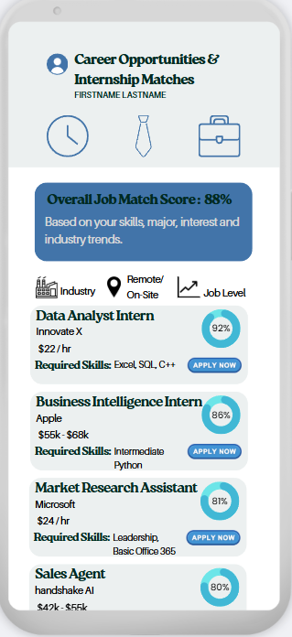
Students’ access interfaces depict a full lifecycle system that fulfills M&A’s vision: guiding each student from high-school exploration to college decisions, career development, real experience, and ultimately, professional workforce entry.

6.2 Activity Diagram
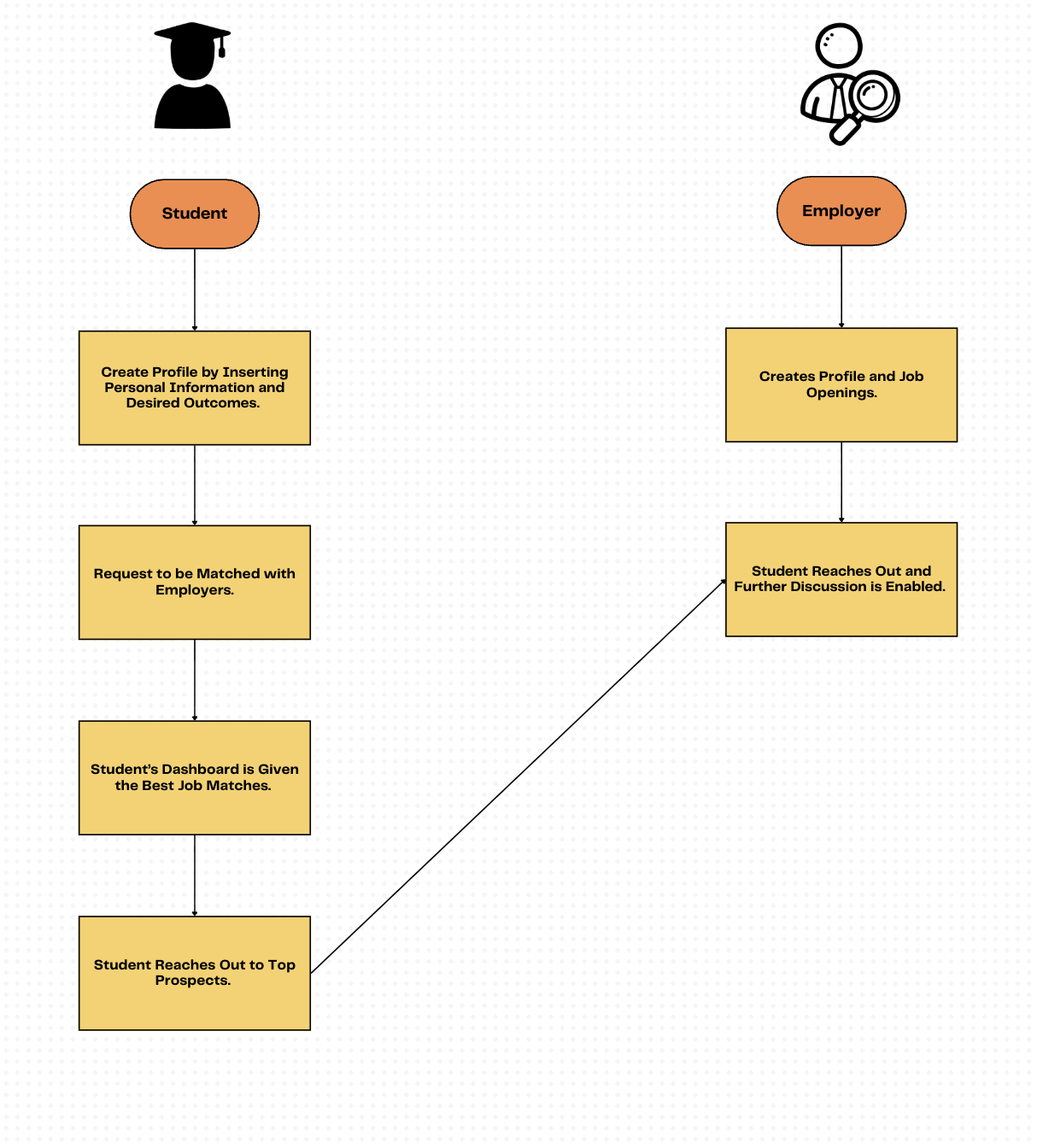

6.3 Supporting ERM
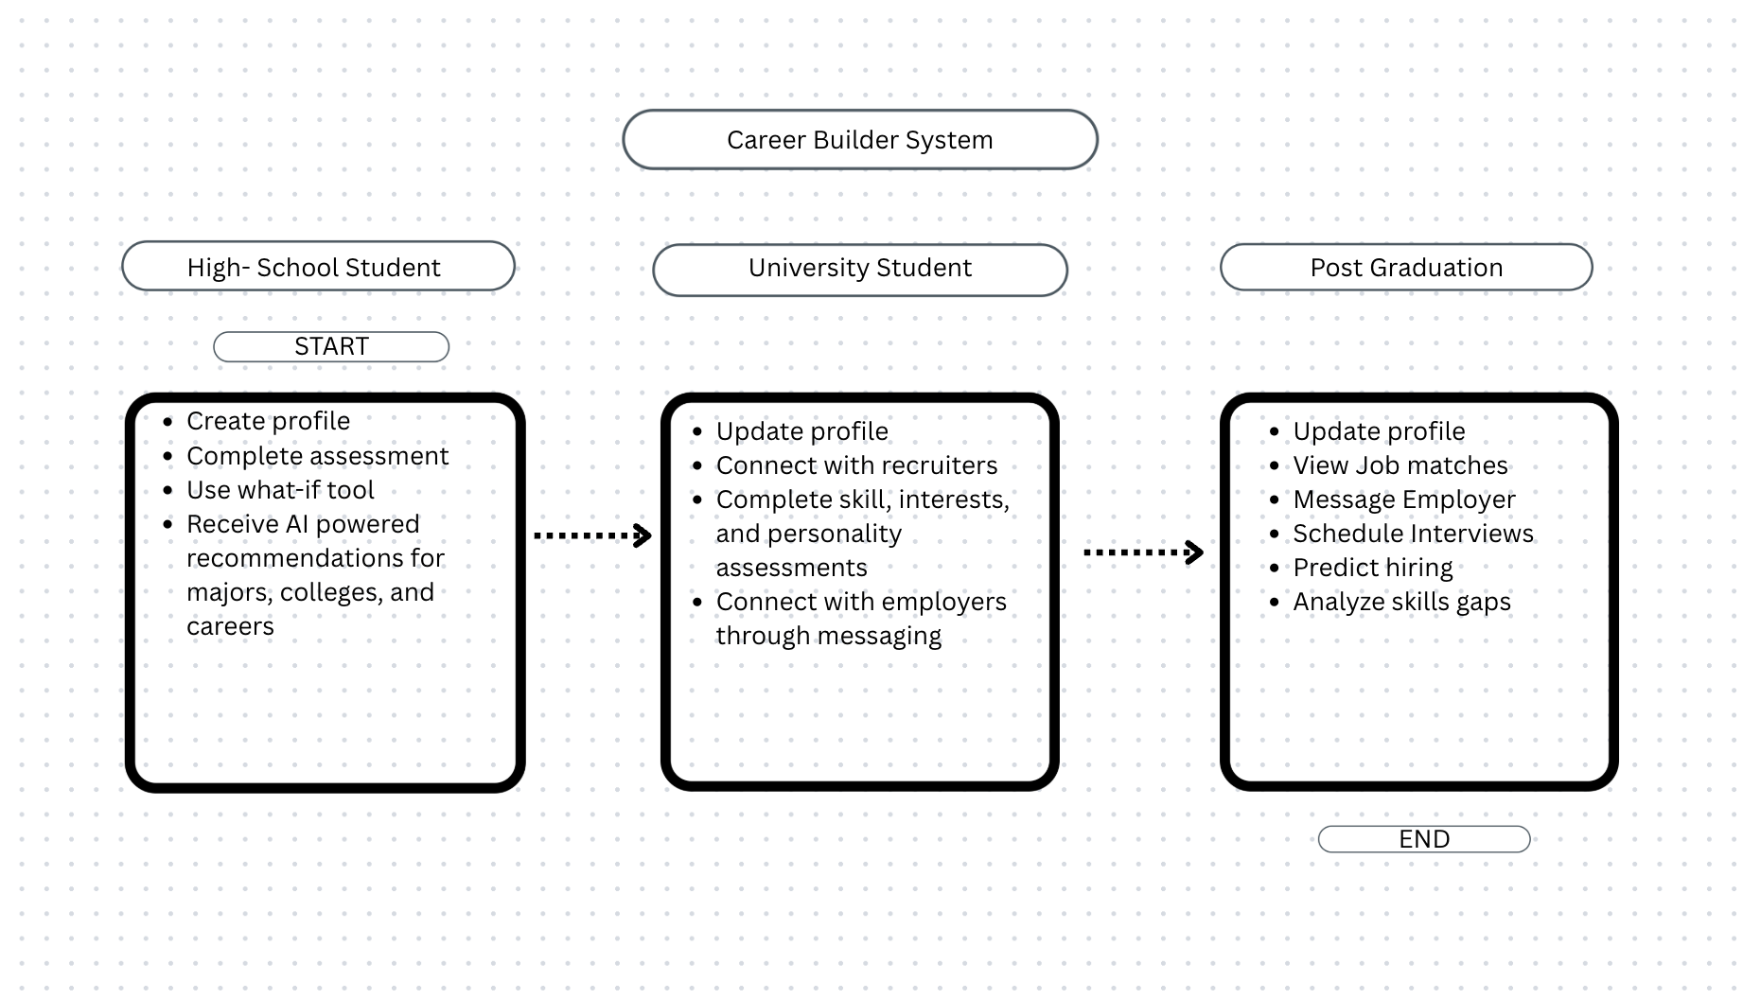

6.4 User Flow Sequence
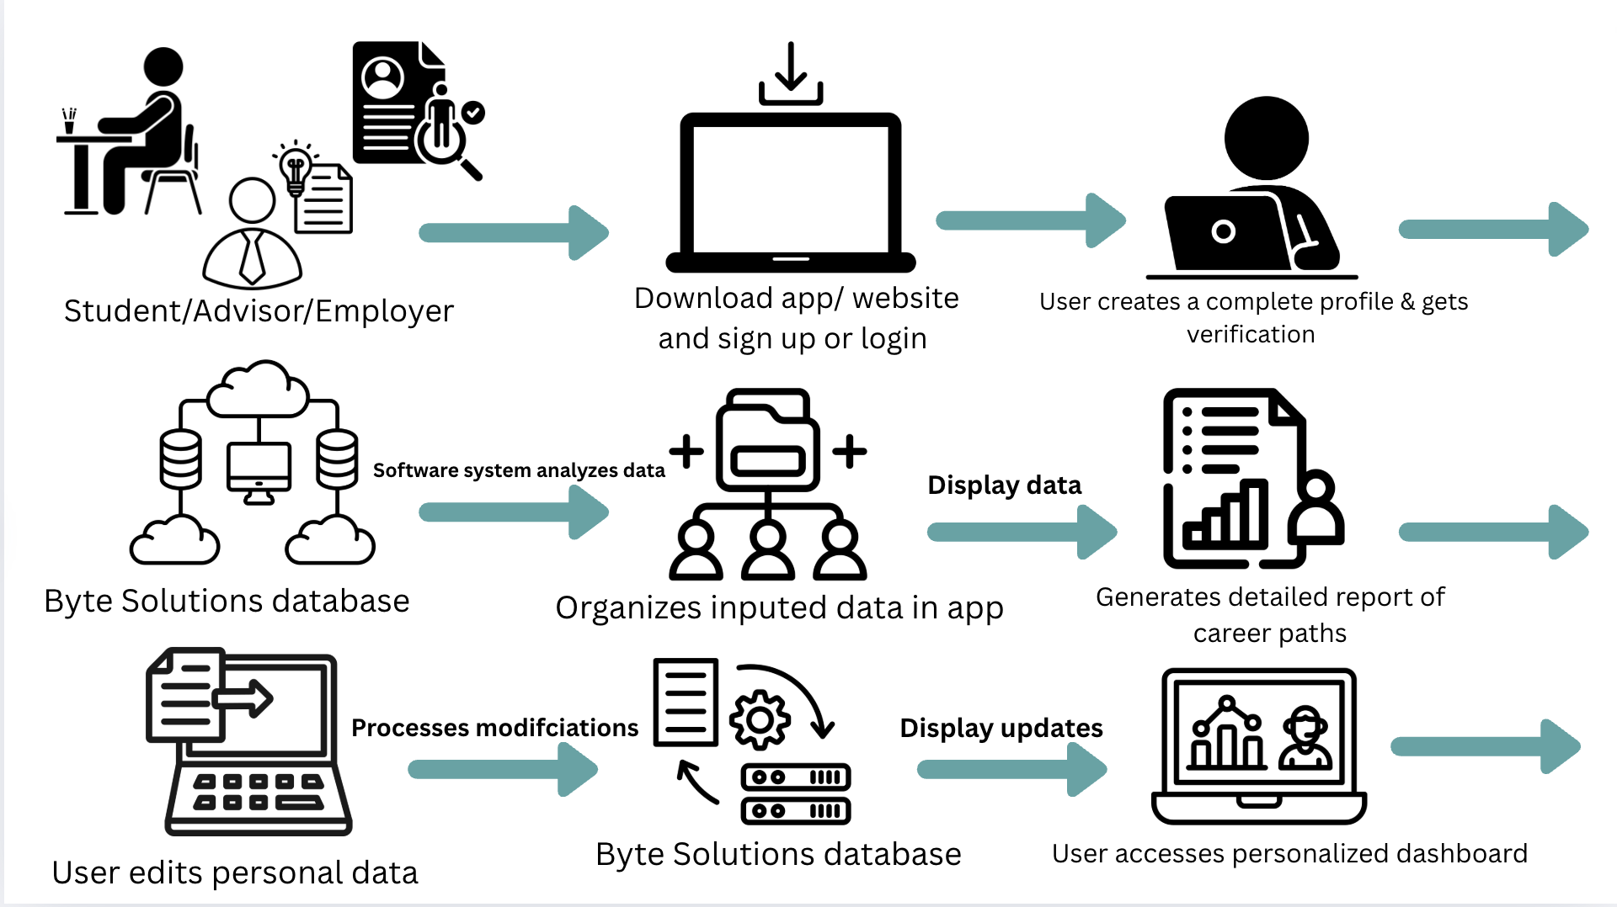

Section 7: Mock Prototype Demonstration

7.1 Potential Use Cases:

7.1.1 Student User Use Cases:
Use Case: Student to Employer Matching
Goal: To be matched with employer that is in line with both the Student’s and Employers desired outcomes.
Process:
- Student has created a profile and set preferences
- Student requests to be available and open to Employers.
- The system uses the student’s profile and Employers’ profiles to find the best matches for both parties.
- The Employers and their information are given to the student’s dashboard.
Requirements: Student’s profile, Student’s consent to be matched, and Employers’ profile/job opening.
Use Case: Student Profile Creation and Management
Goal: To create and maintain an up-to-date personal profile that informs recommendations and matching.
Process:
- Students create an account.
- Student inputs demographic, academic, and personal information.
- Student updates profile as needed over time (courses, skills, activities, experiences).
- System stores and uses profile data to improve recommendations and matching.
Requirements: Student profile, secure account login, editable information fields.
Use Case: Complete Assessments (Skills, Interests, Personality)
Goal: To receive accurate insights and tailored recommendations based on assessment results.
Process:
- Student accesses assessment tools within the platform.
- Student completes skills, interest, and personality evaluations.
- System analyzes results using AI models.
- Assessment outcomes feed into academic and career recommendations.
Requirements: Assessment tools, student participation, AI analysis engine.
Use Case: AI-Generated Major/College/Career Recommendations
Goal: To receive personalized recommendations aligned with student strengths and goals.
Process:
- Student completes profile and assessments.
- System analyzes the student’s data using recommendation algorithms.
- System generates ranked lists of majors, schools, and careers.
- Recommendations populate in the student dashboard.
Requirements: Student profile, assessment results, recommendation engine.
Use Case: What-If Scenario Academic/Career Path Comparison
Goal: To explore hypothetical outcomes of different educational or career decisions.
Process:
- Student selects two or more academic or career options.
- Student inputs variables (major choice, location, salary preference, etc.).
- System generates side-by-side projections of outcomes.
- Student evaluates the scenarios to guide decision-making.
Requirements: Student profile, scenario modeling tool, outcome projection data.
Use Case: View Predicted Career Outcomes
Goal: To make informed decisions using future-focused career data.
Process:
- Student selects a career or job field.
- System displays projected salary ranges, job demand, necessary skills, and growth trends.
- Students saves or compare career options.
Requirements: Labor market data, career analytics engine.
Use Case: Search & Explore Programs, Scholarships, and Opportunities
Goal: To find educational and financial opportunities that align with goals.
Process:
- Student uses search filters (major, location, GPA, etc.).
- System retrieves relevant programs and scholarships.
- Student saves, compares, or applies through the platform.
Requirements: Program and scholarship database; student profile filters.
Use Case: Save & Compare Schools, Majors, and Jobs
Goal: To organize and evaluate potential options easily.
Process:
- Student bookmarks schools, majors, or job opportunities.
- System saves selections in the dashboard.
- Student compares them using built-in comparison tools.
Requirements: Student account saved items functionality, comparison tool.
Use Case: Messaging & Event Connections with Universities/Employers
Goal: To communicate directly with recruiters or representatives.
Process:
- Student views university/employer profiles.
- Student messages reps or registers for events.
- System enables real-time chat or event attendance tracking.
Requirements: Messaging tool, event system, student profile.
Use Case: Track Applications & Deadlines
Goal: To stay organized throughout the application process.
Process:
- Student inputs application details.
- System syncs program deadlines and reminders.
- Student checks dashboard for progress and upcoming dates.
Requirements: Application tracking tool, deadline database.

7.1.2 University User Use Cases:
Use Case: University Profile Creation & Management
Goal: To present accurate, appealing information to prospective students.
Process:
- University creates an institutional profile.
- University uploads program info, admissions criteria, scholarships, and events.
- System displays information to students who match relevant criteria.
Requirements: University account, program information database.
Use Case: Post & Update Programs, Scholarships, Events
Goal: To maintain relevant offerings and promote opportunities.
Process:
- University enters details for each program or opportunity.
- System organizes listings and pushes updates to interested students.
Requirements: University portal, listing update tools.
Use Case: View Matched Students
Goal: To identify prospective students who align with program interests and requirements.
Process:
- University accesses matching dashboard.
- System displays students whose preferences and scores align.
- University reviews student profiles.
Requirements: Student profile access permissions, matching engine.
Use Case: Communicate with Students
Goal: To engage potential applicants through messages and events.
Process:
- University selects matched or interested students.
- University sends messages or invites them to live events.
- Students respond through the platform.
Requirements: Messaging system, student communication permissions.
Use Case: Access Analytics Dashboard
Goal: To make data-driven decisions using AI insights.
Process:
- University opens analytics view.
- System displays insights on interest trends, program popularity, and predicted enrollment.
- University uses data to adjust programs or outreach.
Requirements: Analytics engine, aggregated student data.
Use Case: Host Virtual Recruitment Sessions
Goal: To reach more students through digital engagement.
Process:
- University schedules a virtual session.
- System notifies relevant students.
- Students attend via built-in event tools.
Requirements: Event hosting tools, video/webinar integration.

7.1.3 Employer User Use Cases:
Use Case: Employer Profile Creation & Management
Goal: To present company information and attract qualified talent.
Process:
- Employers create company profiles.
- Employers upload mission, values, departments, and workplace details.
- System displays company profiles to relevant students.
Requirements: Employer account, profile builder.
Use Case: Post Job/Internship/Training Opportunities
Goal: To attract candidates to open positions.
Process:
- Employer adds job listings with required qualifications.
- System organizes and promotes listings to matched students.
- Students explore and apply.
Requirements: Job posting tool, student matching system.
Use Case: View Matched Student Candidates
Goal: To efficiently identify top applicants aligned with company needs.
Process:
- Employer opens talent pipeline dashboard.
- System presents matched student profiles based on skills and goals.
- Employer reviews, shortlists, or contacts candidates.
Requirements: Student profile access permissions, matching algorithm.
Use Case: Communicate with Students (Messages, Interviews, Events)
Goal: To connect with potential hires and schedule next steps.
Process:
- Employer selects students of interest.
- Employer sends messages, interview invites, or event invitations.
- Students respond and attend sessions.
Requirements: Messaging system, event scheduling, interview tools.
Use Case: Workforce Trend & Skill Gap Analysis
Goal: To understand talent availability and future workforce needs.
Process:
- Employer accesses analytics dashboard.
- System displays insights on student skill trends, emerging fields, and shortages.
- Employer adjusts hiring strategy accordingly.
Requirements: Analytics engine, aggregated talent data.

7.2 Financial Impact
Prepared for Madden & Associates
Supporting the Longevity Platform Proposal

Introduction
The proposed Longevity Platform designed by our team Byte Solutions provides substantial financial impact for Madden & Associates, partnering Universities, employers, and students. This financial impact statement evaluates the implications of the system across cost efficiency, revenue generation, and long-term economic value creation. The analysis draws on system capabilities, strategic requirements, and A.I.-enabled forecasting outlined throughout the proposal.

Summary of Investment
Madden & Associates anticipates allocating $10 million toward the development, deployment, and early-stage operation of the platform. This investment is distributed across four major categories.
Core System Development
- Platform architecture
- Database, ERM, and database integration design
- Security, encryption, and compliance controls
- Priority matrix, trait trackers, university selector, employer portal
- UI/UX and multi-device accessibility
Artificial Intelligence Capabilities
- Career recommendation engine
- Financial forecasting models
- NLP-based job description analysis
- A.I. scenario modeling
- Trait tracker scoring and predictor models
Implementation and Go-Live
- Multi-University onboarding
- Data cleansing and normalization
- Model training, testing and monitoring
- User acceptance testing
Ongoing Operations (Years 1-3)
- Cloud computing and hosting
- Ongoing A.I. retraining
- System maintenance and monitoring
- Support and content governance

ROI Timeline
Year | Initial Investment | Cumulative Returns | Net Position
Year 0 | -10,000,000 | 0 | -10,000,000
Year 1 | 0 | 3,000,000 | -7,000,000
Year 2 | 0 | 7,000,000 | -3,000,000
Year 3 | 0 | 12,000,000 | 2,000,000
Year 4 | 0 | 18,000,000 | 8,000,000
Year 5 | 0 | 25,000,000 | 15,000,000

Break-even occurs between Year 2-3, with strong net gains in later years.

Cost Break Down of $10M investment
Cost Category | Amount (Millions USD) | % of total
System Development | 4,000,000 | 40%
AI Capabilities | 2,500,000 | 25%
Implementation & Development | 2,000,000 | 20%
Operation (Years 1-3) | 1,500,000 | 15%
Total | 10,000,000 | 100%

Revenue Generation (Projected Annual Revenue Streams)
Revenue Source | Description | Projected Annual revenue (Millions USD) | Notes
University Licensing Fees | Subscription fees paid by universities to access to platform | 2,000,000 – 4,000,000 | Based on number of schools onboarded
Employer recruiting Subscriptions | Employers pay for access to the talent matching portal and analytics | 1,500,000-3,000,000 | Scales as more schools enters the ecosystem
Premium Student Services (optional) | Advanced assessments, personalized coaching, and career simulations. | 500,000-1,000,000 | Optional monetization, depends on the model
Alumni and Engagement & Donation Uplift | Increased alumni giving due to stronger long-term engagement. | 1,000,000-2,000-000 | Value realized by universities, improves ROI case
Data and Analytics Packages | Insight dashboards sold to universities, employers, and workforce partners. | 500,000-1,500,000 | Includes labor market forecasting & skill gap analytics
Consulting and Implementation Services | Professional services for new universities, custom integrations | 1,000,000-1,500,000 | High-margin service for M&A
Total Estimated Revenue | - | 6,500,000-13,000,000 | Platform likely becomes self-sustaining by Year 3

Section 8: Executive Readout

Presentation Recording Link:
https://youtu.be/W9758IfIlHo

